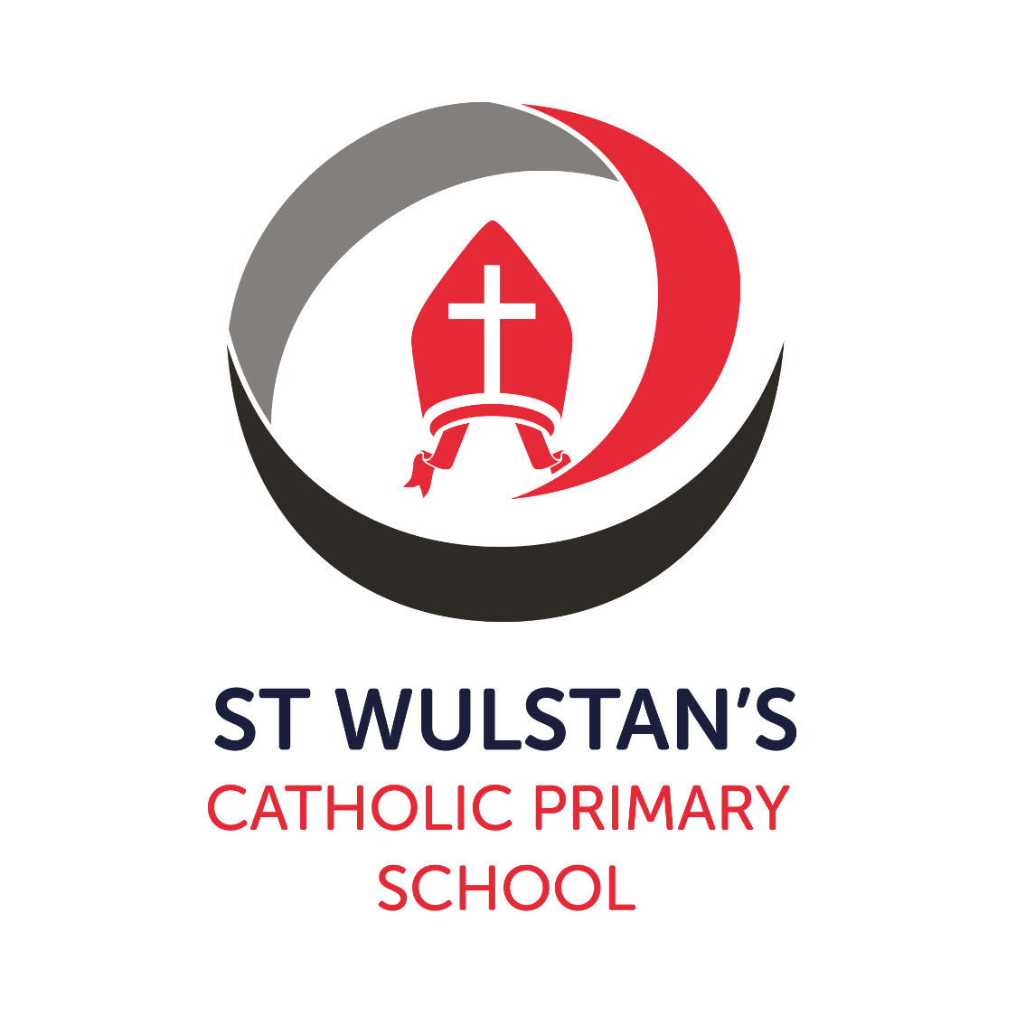
Relationships and Sex Education Policy

Version: | 1
Date created/updated: | September 2023
Ratified by: | Mrs Jenn Hill
Date ratified: | October 2023
Date issued: | October 2023
Policy Review Date: | September 2024
Post Holder Responsible for Review: | Mrs Fiona Freitas

Commitment to Equality:

We are committed to providing a positive working environment which is free from prejudice and unlawful discrimination and any form of harassment, bullying or victimisation. We have developed. a number of key policies to ensure that the principles of Catholic Social Teaching in relation to human dignity and dignity in work become embedded into every aspect of school life and these. policies are reviewed regularly in this regard.

This Relationships and Sex Education Policy has been approved and adopted by St Wulstan’s Catholic Primary School on October 2023 and will be reviewed in October 2023.

Signed by the Chair of the Local Governing Body for St Wulstan’s Catholic Primary School:

Mrs Jenn Hill

J.Hill

Signed by the Executive Principal for St Wulstan’s Catholic Primary School:

Mrs Emma Brocklesby

E.Brocklesby
Contents Page

1 Safeguarding 4

2 The Catholic Curriculum 4

3 GDPR and Data Protection 5

4 Introduction 5

5 Policy Rationale 5

6 Implementation and Review 6

7 Dissemination 6

8 Defining Relationships and Sex Education 6

9 Curriculum 6

10 Pupil’s Learning and Understanding 8

11 Outcomes 8

12 Equalities Obligations 8

13 Children’s Questions 8

14 Controversial or Sensitive Issues 8

15 Confidentiality and Advice 9

16 Right to Withdraw 9

17 Roles and Responsibilities 10

18 Monitoring and Evaluation 11

19 Policy Access 11

20 Related Policies 11

DEFINITIONS

The Company’s standard set of definitions is contained at Definition of Terms – please refer to this for the latest definitions.

- Safeguarding

  - At Saint Wulstan’s Catholic Primary School we play a crucial role in preventative education. Preventative education is a whole school approach in Relationships and Sex Education (RSE) that prepares pupils for life in modern Britain and creates a culture of zero tolerance for sexism, misogyny/misandry, homophobia, biphobia and sexual violence/harassment. We have a clear set of values and standards, upheld and demonstrated throughout all aspects of RSE.
  - The RSE curriculum is inclusive and developed to be age and stage of development appropriate.
  - Effective RSE will provide opportunities for discussion of what is and is not appropriate in relationships. Such discussion may well lead to disclosure of a safeguarding issue.
  - Teachers will need to be aware of the needs of their pupils and not let any fears and worries go unnoticed.
  - Where a staff member suspects that a child or young person is at risk or they are made aware of a disclosure they are required to follow the school’s safeguarding policy and immediately inform the Designated Safeguard Lead.

- The Catholic Curriculum

  - Through the development of a Catholic Curriculum all staff have the knowledge and understanding of the Catholic Social Teaching themes. Staff ensure that through the (subject) curriculum there are opportunities for the pupils to develop their own knowledge and understanding of the key principles of the Catholic Social Teaching themes.
  - Pupils are also encouraged to use this gained understanding to make, age-appropriate links to their everyday lives and the world around them. The CAFOD resources are used to support this learning and it is also enhanced through trips, visitors to school and experiential days as well as involvement in charitable organisations.
  - The Catholic School Pupil Profile is also linked to the Catholic Curriculum and the appropriate virtues are chosen and celebrated through the RSE curriculum. The virtues that are chosen for the RSE curriculum are:
- Grateful & Generous
- Attentive & Discerning
- Compassionate & Loving
- Faith-filled & Hopeful
- Eloquent & Truthful
- Learned & Wise
- Curious & Active
- Intentional & Prophetic
- GDPR and Data Protection

  - This policy adheres to the principles under data protection law. For further information please review the school’s data protection policy published on the school’s website.

- Introduction

  - As of September 2020, Relationships and Sex Education (RSE) is a compulsory part of every school’s taught curriculum to embrace ‘…the challenges of creating a happy and successful adult life’ by giving pupils knowledge ‘…that will enable them to make informed decisions about their well-being, health and relationships’ (Department for Education). The Department for Education (DfE) guidance defines RSE as ‘…lifelong learning about physical, moral and emotional development. It is about the understanding of the importance of marriage and family life, stable and loving relationships, respect, love and care. It is also about the teaching of sex, sexuality and sexual health.’

- Policy Rationale

  - The Governing Body and teachers, in partnership with pupils and their parents, set out their intentions about relationships and sex education (RSE) and our rationale for and approach to RSE in school.
  - The school’s policy and scheme of work draws on a review of the existing RSE curriculum, adopting the new approach to the delivery of RSE to meet the statutory requirements outlined by the DfE, but also maintain that we are involved in relationships and sex education precisely because of our Christian beliefs about God and about the human person.
  - The belief in the unique dignity of the human person made in the image and likeness of God underpins the approach to all education in a Catholic school. Our approach to RSE therefore is rooted in the Catholic Church’s teaching of the human person and is presented in a positive framework of Christian ideals. This methodology supports the vision of the Catholic Education Service (CES) which insists that we should emphasise ‘…the importance of healthy relationships to human well-being, as the core learning within an RSE curriculum.’ (A model Catholic Primary RSE Curriculum 2019)
  - We endeavour to deliver a fully integrated and holistic programme in Relationship Education that fully enables our children to ‘…live life to the full’ (John 10:10) and keep Christ at the centre of all that we do.

- Implementation and Review

  - Implementation of the policy took place after consultation with the Local Governing Body in Autumn term 2021.
  - The policy will be reviewed every two years by the Principal, RSE Coordinator, the Local Governing Body and Staff. The next review date is September 2025.

- Dissemination

  - This policy will be given to all members of the local Governing Body, and all teaching and nonteaching members of staff. Copies of the document including details of the content of the RSE curriculum will be available to all parents through the school’s website and on request from the school office. Details of the content of the RSE curriculum will also be published on the Ten:Ten Parent Portal.

- Defining Relationships and Sex Education

  - The DfE guidance states that “children and young people need to know how to be safe and healthy, and how to manage their academic, personal and social lives in a positive way.” It is about the development of the pupil’s knowledge and understanding of him or her as a sexual being, about what it means to be fully human, called to live in right relationships with self and others and being enabled to make moral decisions in conscience.
  - In primary schools, the focus should be on “teaching the fundamental building blocks and characteristics of positive relationships, with particular reference to friendships, family relationships and relationships with other children and with adults.” This would include the topic of families and the people who care for me, caring friendships, respectful relationships, online relationships and being safe.

- Curriculum

  - The programme delivered to our children is supported and resourced by ‘Ten:Ten Resources’ to enhance the approach we take to delivering collective worship across the school. The programme entitled ‘Life to the Full’ is a comprehensive scheme of work in Relationships Education which embraces and fulfils the statutory curriculum.
  - At St Wulstan’s, we have tailored the curriculum to embed full, annual coverage over three terms for each year group. The approach we take to revisit content over a one year cycle will allow the children to consolidate and deepen their understanding in line with their changing bodies, minds and relationships with faith. The programme is categorised into three key areas:

- Created and loved by God
- Created to love others
- Created to live in community
  - All themes are taught through a story known as ‘Kester’s Adventures’ in which the teaching of physical, moral and social development is explored.
  - The programme is taught from Year One until Year Six, ensuring children are able to learn and grow in light of Christian beliefs to understand how they are created in the image and likeness of God. This will be enhanced by our wider curriculum, which is built upon Catholic Social Teaching and the Catholic Profile Virtues and Values.
  - All lessons will be delivered by class teachers, who have received sufficient training to enhance children’s development and handle questions with sensitivity and in light of Catholic Social Teaching. All teachers are confident in adapting teaching methods to meet the varying needs of this group of pupils.
  - The age-appropriate programme aims to:
- To develop an understanding of our relationship with God and one another and how we live our lives to promote loving and meaningful relationships.
- To engender growth in self-respect and self-worth recognising that each of us is created in the image and likeness of God.
- To understand that relationships are based upon love, trust and faith.
- To show an understanding that we are all made in the image of God but that we must develop and sustain meaningful, lasting relationships.
- Enable children to understand themselves, their bodies and their emotional development.
- Enable children to grow in understanding of family life as an important and special gift from God.
- Enable children to develop skills which enable them to live as an important and special gift from God.
- Enable children to develop skills which will enable them to live in families and other social groups as a response to their commitment to Christ.
- Enable children to learn skills which help them form friendships and relationships.
  - These specific aims will be achieved in the delivery of various topics including: personal health; physical and emotional wellbeing; strong emotions; private parts of the body; personal relationships; family structures; trusted adults; growing bodies; puberty; menstruation; life cycles; the dangers of social media; pornography; where babies come from; an understanding of the Common Good and living in the wider world.

- Pupil’s Learning and Understanding

  - Pupils’ learning in RSE will be assessed through formative approaches such as 1:1 discussion, contributions to lessons, contributions to group work, content of written work as well as summative approaches such as tests assessing prior knowledge and a test at the end of each unit to assess progress.
  - Children will complete work in their RSE exercise books which will journey with them through their time at St Wulstan’s.

- Outcomes

  - The delivered programme is sensitive to the difference needs of individual pupils in respect to pupils’ different abilities, levels of maturity and personal circumstances; for example their own sexual orientation, faith or culture and is taught in a way that does not subject pupils to discrimination.

- Equalities Obligations

  - The Local Governing Body have wider responsibilities under the Equalities Act 2010 and will ensure that our school strives to do the best for all of the pupils, irrespective of disability, educational needs, race, nationality, ethnic or national origin, pregnancy, maternity, sex, gender identity, religion or sexual orientation or whether they are looked after children.
  - Equal time and provision will be allocated for all groups but there may be occasions where children with Special Educational Needs are given extra support.

- Children’s Questions

  - The Local Governing Body want to promote a healthy, positive atmosphere in which RSE can take place. They want to ensure that pupils can ask questions freely, be confident that their questions will be answered, and be sure that they will be free from bullying or harassment from other children and young people.

- Controversial or Sensitive Issues

  - There will always be sensitive or controversial issues in the field of RSE. These may be matter of maturity, of personal involvement or experience of children, of disagreement with the official teaching of the Church, of illegal activity or other doubtful, dubious or harmful activity.
  - The Governors believe that children are best educated, protected from harm and exploitation by discussing such issues openly within the context of the RSE programme.
  - The use of ground rules, negotiated between teachers and pupils, will help to create a supportive climate for discussion. (See also Sex and Relationship Guidance, 4.5 ‘Dealing with questions’ 0116/2000, Department for Education and Employment, July 2000 for more detail)
  - Some questions may raise issues which it would not be appropriate for teachers to answer during ordinary class time, e.g., where a child or young person’s questions hints at abuse, is deliberately tendentious or is of a personal nature.
  - Children will be referred to the most appropriate person in school or at home to deal with their questions or comments.

- Confidentiality and Advice

  - All Governors, all teachers, all support staff, all parents and all pupils must be made aware of this policy, particularly as it relates to issues of advice and confidentiality.
  - All lessons, especially those in the RSE programme, will have the best interests of pupils at heart, enabling them to grow in knowledge and understanding of relationships and sex, developing appropriate personal and social skills and becoming appreciative of the values and attitudes which underpin the Christian understanding of what it means to be fully human. Pupils will be encouraged to talk to their parents/carers about the issues which are discussed in the programme.
  - Teachers will always help pupils facing personal difficulties, in line with the school’s pastoral care policy.
  - Teachers should explain to pupils that they cannot offer unconditional confidentiality, in matters which are illegal or abusive for instance.
  - Teachers will explain that in such circumstance they would have to inform others, e.g., parents, Principal, but that the pupils would always be informed first that such action was going to be taken.

- Right to Withdraw

  - Parent consultations will form part of the implementation of the new statutory RSE curriculum at St Wulstan’s. Discussion will be had about the content of the curriculum and how the school wishes to proceed in delivering sex education as part of the RSE curriculum keeping the values of the Gospel at the heart of our teaching.
  - Parents and carers cannot withdraw their child from: relationships education, health education or National Curriculum Science.
  - Prior to the teaching of sex education at an age-appropriate level, parents/guardians will be given an opportunity to request to withdraw their child from all of part of sessions involving sex education.
  - In keeping with guidance from the DfE, any such request will only be granted once a conversation has taken place with the school Principal about the benefits of receiving this important education and any detrimental effects that withdrawal might have on the child – school will document this process to ensure a record is kept and the Local Governing Body will be notified.
  - After discussions have taken place, except in exceptional circumstances, the school will respect the parents’ request to withdraw the child. The Principal will automatically grant a request to withdraw a child from any sex education delivered in school, other than as part of the statutory Science curriculum.

- Roles and Responsibilities

  - Contributors to the development of the RSE curriculum and this policy include:
Principal | The Principal takes overall delegated responsibility for the implementation of the RSE curriculum and this policy. They will deal with any requests from parents to withdraw their child from the curriculum. They will maintain the role of liaison for the Local Governing Body, parents, the Diocesan Schools’ Service, the Emmaus MAC, the Local Education Authority, and any other appropriate agencies.
Local  Governing  Body | The Governing Body will keep up to date the school’s policy for RSE, in consultation with parents and will make copies of the policy available to them. They will make known to parents their right to withdraw their children from Sex Education provided at school except for those parts included in the Statutory National Curriculum.
Teachers | All teachers have a responsibility of care; as well as fostering academic progress they should actively contribute to the guardianship and guidance of the physical, moral and spiritual well-being of their pupils. Teachers will be expected to teach RSE in accordance with the catholic ethos of the school. Appropriate training will be made available for all the staff teaching RSE.
All staff | RSE is a whole school issue. All teachers have a responsibility of care; as well as fostering academic progress, they should actively contribute to the guardianship and guidance of the physical, moral and spiritual well-being of their pupils. Teachers will be expected to teach RSE in accordance with the Catholic Ethos of the school. Appropriate training will be made available for all staff teaching RSE. All staff have been included in the development of this policy and all staff should be aware of the policy and how it relates to them.
RE/RSE Lead | Responsible for the development of the curriculum, delivering training and resources to key members of staff, monitor the teaching of the subject and work with partners including the safeguarding lead and external visitors.
Designated  Safeguard  Lead (DSL) | Responsible for checking policy for safeguarding compliance and dealing with safeguarding matters as and when they arise.
Parents | School recognises that parents are the primary educators of their children and school will seek to support them in this task. They will ensure that parents are kept informed of what is happening in RSE, and of our expectations of their children. The school will provide support to those parents/guardians who request to withdraw their child from sex education by providing material for parents to help the children with their learning.
External  Visitors | Visits will always complement the current programme and never substitute or replace teacher led sessions. It is important that any external visitor is clear about their role and responsibility whilst they are in school delivering a session. Any visitor must adhere to our code of practice developed in line with CES guidance  ‘Protocol for Visitors to Catholic Schools’  Health professionals should follow the school’s policies, minimising the potential for disclosures or inappropriate comments using negotiated ground rules and distancing techniques as other teachers would. They will ensure that all teaching is rooted in Catholic principles and practice.

- Monitoring and Evaluation

  - The Principal and RSE lead will be responsible for monitoring and evaluating the subject – this will comply with the school policy for monitoring.
  - The impact of the curriculum and the policy will be reviewed based on findings.
  - The Local Governing Body will be kept up-to-date on RSE matters, as will the SLT.

- Policy Access

  - In this policy the Governors and teachers, in partnership with pupils and their parents, set out their intentions for RSE.
  - The policy will be given to all members of the Local Governing Body, and all teaching and non-teaching members of staff.
  - Copies of the document will be available to all parents through the school’s prospectus and will be published on the school’s website – along with an overview of the content of the RSE curriculum.

- Related Policies

  - Child Protection and Safeguarding
  - Behaviour and Discipline Policy
  - Equality Policy
  - Anti-Bullying
  - Online Safety Policy
  - Subject Specific Policies

